

Business Requirement Definition:

**Security Transport Application**

Foskor ICT

Acid Division

Date: 12th October 2020

Version: 1.1

# Document Control

|  |  |  |  |
| --- | --- | --- | --- |
| Role | Name | Date | Version |
| Author | Yolisa Nogantshi | 14/10/2020 | 1.1 |
| Author | Mpho Cele | 14/10/2020 | 1.1 |
| Approver | Nomsa Sibeko | 14/10/2020 | 1.1 |

Contents

Document Control 2

INTRODUCTION 4

Background 4

Overview 4

Responsibilities 4

High Level “As Is” Business Processes 5

Gaps 11

Recommendations 11

High Level “To Be” Business Processes 12

Specifications 14

Software Tools 14

Programming languages 14

Development Environments 14

Database Schema 14

# INTRODUCTION

This document provides a formal statement of the business process requirements for the Security Transport Application and forms part of the Definition phase of the project.

The document details the “As Is” and “To Be” process requirements, identified gaps and recommendations.

# Background

The transport application is used to record trips taken by drivers from Kenyon Security Services. The drivers transport Foskor employees to various destination when the need arises. Kenyon Security Services uses the application to keep records which will be reported to Foskor for invoicing.

The current application does not allow the records to be captured accurately. This has created the need for a new application to be developed, as the existing one is outdated and the methods for modification have not been documented.

# Overview

The Definition phase activity consists of obtaining the system functionality requirements from the users of the current application.

# Responsibilities

|  |  |  |
| --- | --- | --- |
| Role | Name | Title |
| Foskor Process Owner | Shawn van Rensburg | Security Site Manager |
| Foskor Process Operators | Simphiwe Mthethwa | Visitors Reception Clerk |

# High Level “As Is” Business Processes

The transport request process is initiated by a manual process where a user has a need to be transported to a certain destination. The reasons for the request vary. The transport is done by drivers from Kenyon Security Services, or KSS. KSS is responsible for recording the trips and then reporting them to the Foskor Finance department for invoicing. Certain steps are processed in Microsoft Access (2010) and Microsoft Excel (2016) to facilitate this invoicing.

From initiation of the request, the steps are as follows:

1. A user requires transport. Examples of reasons for this are overtime, call-out, emergencies, etc.
2. When a user requires transport, the Security Controller in the control room is informed (e.g. by phone, walk in, email, etc.).
3. The “Request for Transport” form (of which hardcopies are available in the Security Control Room – see Figure 3: Example of "Request for Transport" form) is completed:
   1. The Security Controller completes the first section of the “Request for Transport” form, which requires details about the transport request such as the requesting passenger, destination, reason for transport, and approval signatures. <explain>
   2. The Security Controller also completes the “Security Control Room use” section of the “Request for Transport” form, which requires details such as the OB in and out numbers, which the Security department uses to index all the jobs completed in a month, and the designated driver.
   3. The Security Controller hands it to the driver to complete the “Security Driver” section of the form, which has details such as the start and end times and kilometer readings, and the destination.
4. The Driver completes the Vehicle register, which keeps the records about each trip per vehicle. This register remains with the Driver for the duration of the shift.
5. The Driver transports the passenger(s) to or from the specified destination, and then returns to Foskor.
6. The Driver completes details about trip after transporting the passenger(s) and takes the “Request for Transport” form to the Clerk.
7. The Clerk captures the data into the form on their Transport record-keeping system, which is on Microsoft Access 2010. Some details cannot be captured accurately due to limitations on the current application. Specifically, the fields for Reasons for Transport, Destination, Driver and Vehicle Used do not allow the options in the drop down menus to be edited. (See Figure 4: Transport form in Microsoft Access - Clerk view)
8. The KSS Supervisor reviews the information in the Transport system Access table and exports the data to Microsoft Excel (2016) for editing.
9. Once the records have been edited, the KSS Supervisor sends a report for invoicing to KSS and the Foskor Finance department.

The diagram below is to illustrate how the process currently flows:

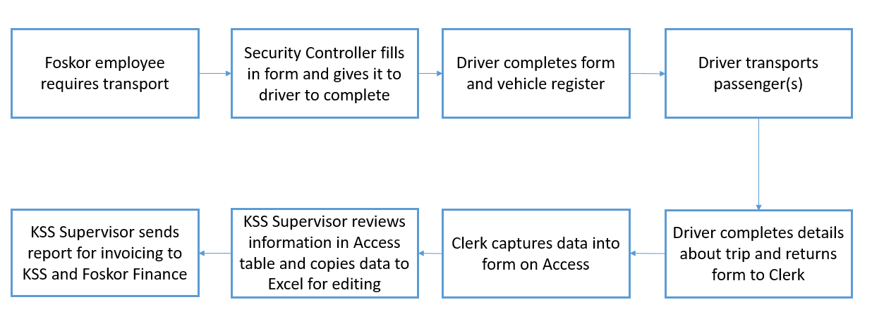

Figure 1: High Level "As Is" Process Flow Diagram

Below is a use case diagram of the process for requesting, capturing and reporting on transport:

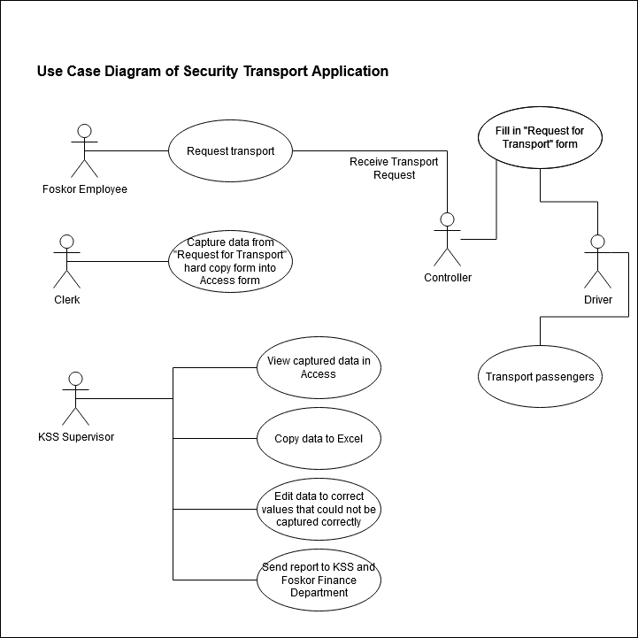

Figure 2: Use Case Diagram of Process Flow

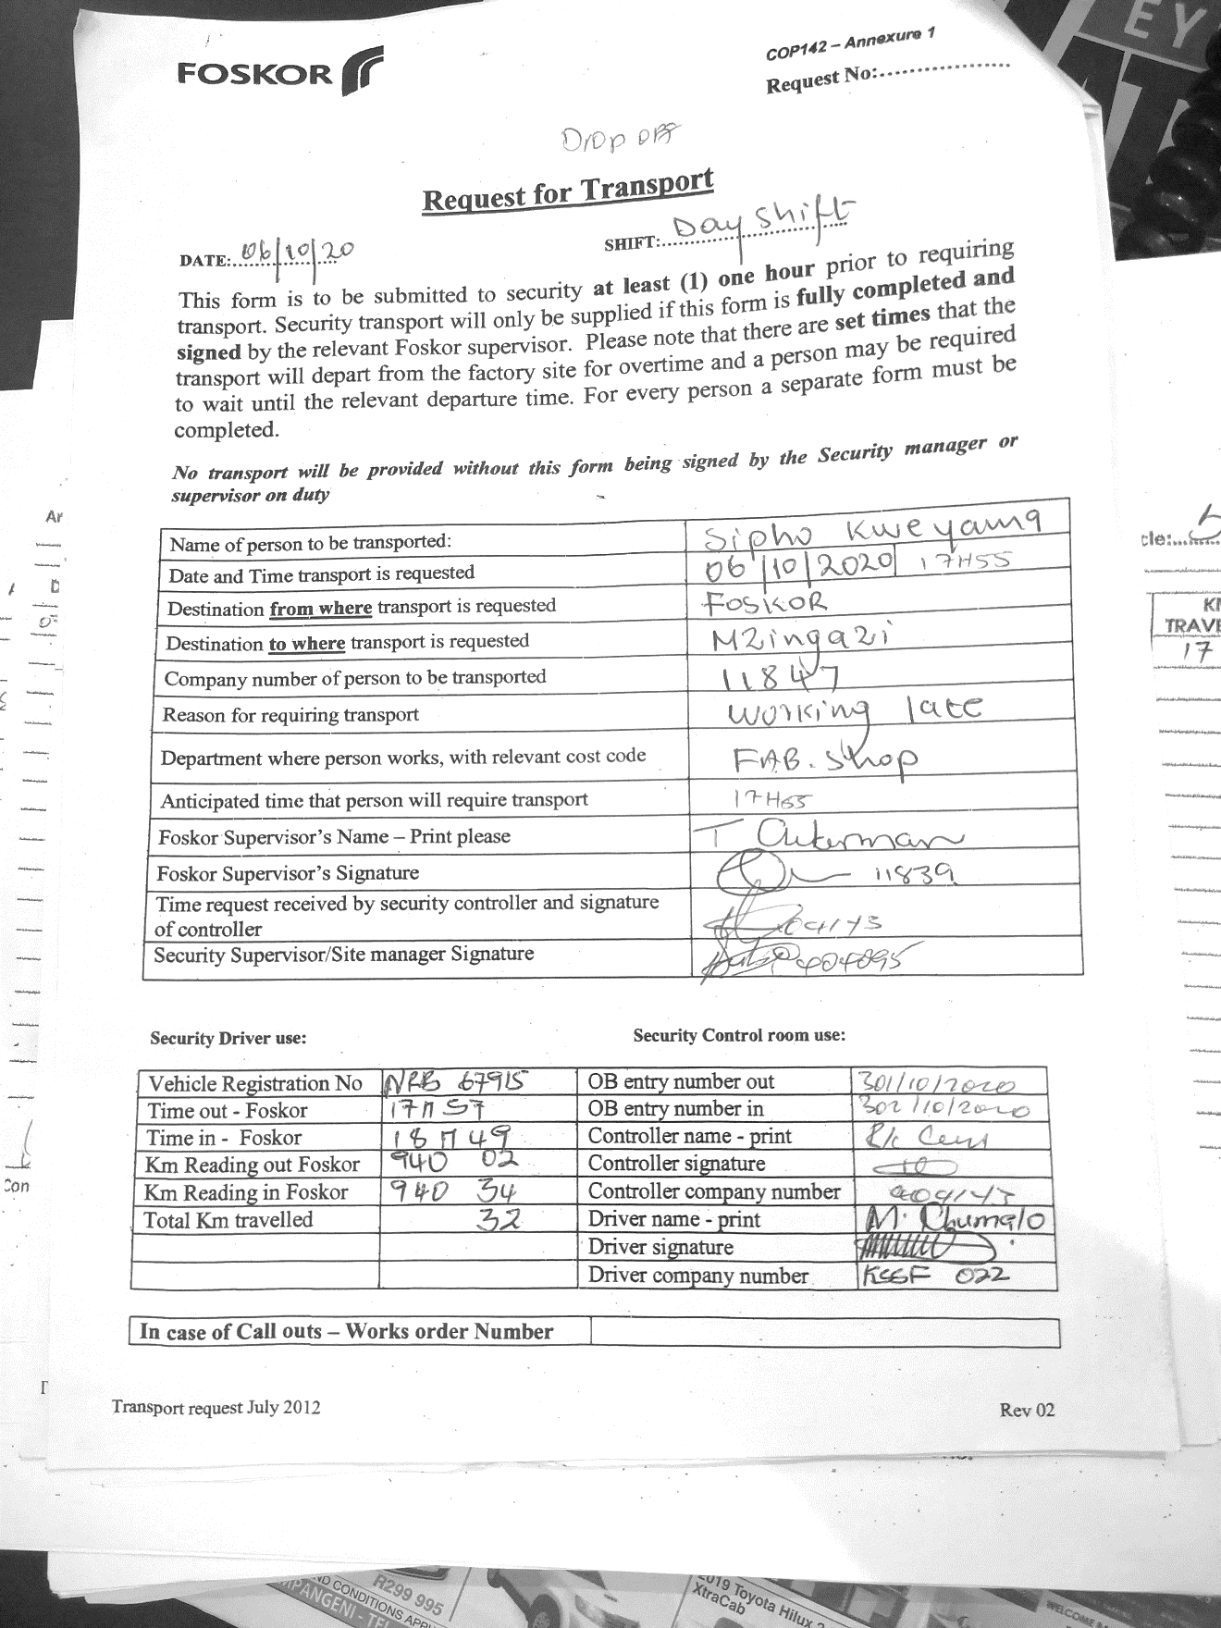

Figure 3: Example of "Request for Transport" form

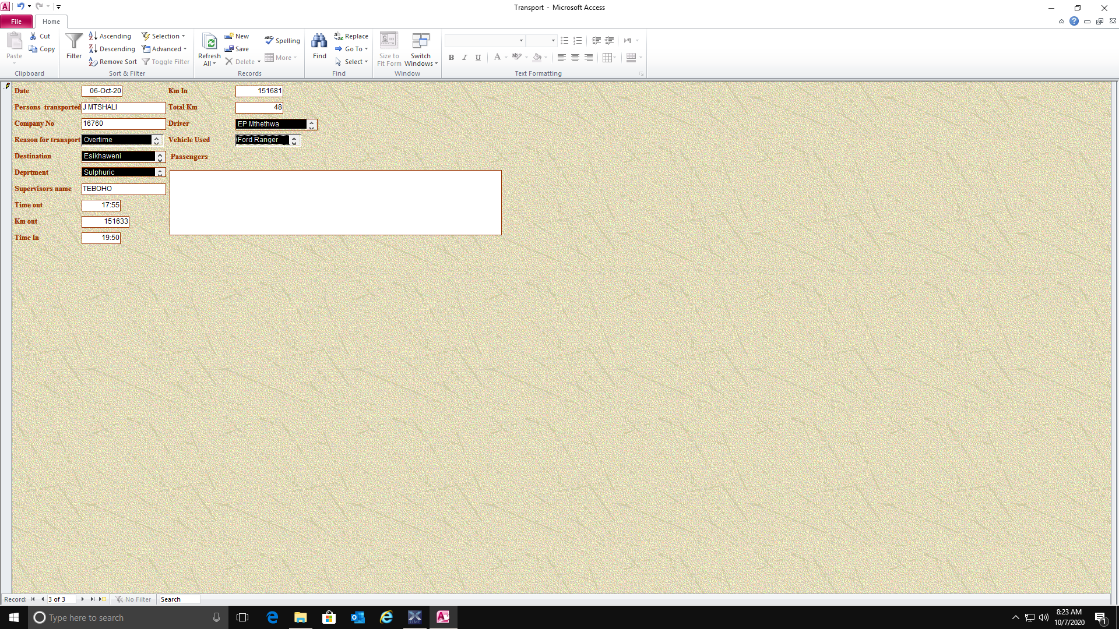

These fields do not allow the user to add or remove pre-populated entries

Figure 4: Transport form in Microsoft Access - Clerk view

## Gaps

1. The Clerk is unable to add or remove entries in the Reason for Transport, Driver, Destination, and Vehicle Make tables. This creates the need for the KSS supervisor to copy the records from Access to Excel, in order to properly capture the details of each trip.
2. The software platform, Microsoft Access 2010, is outdated. Newer versions of Access cannot open the database, and the details of how to edit the database objects have not been properly documented. It is therefore impractical to continue using the same software.
3. The security mechanisms used by the current database are unknown. This makes it difficult for both users and developers to work with the program in the intended manner and to make changes when necessary.
4. <Gap – sub trip handling – ask Shawn how to proceed>

## Recommendations

1. Give the Clerk the ability to add or remove entries in the Reason for Transport, Driver, Destination, and Vehicle Make tables. This should eliminate or reduce the need for the KSS supervisor to edit the records for the report.
2. Create the form and reporting functions in a desktop application. The desktop application should integrate with Microsoft SQL. This will make it standardised with existing Foskor databases and easier to manage.
3. Give the different users roles so that the data is securely available to those who are required to work with it

# High Level “To Be” Business Processes

* Security Admin: The security will have add, delete, edit, update button on the system so that she can be able to make some changes.

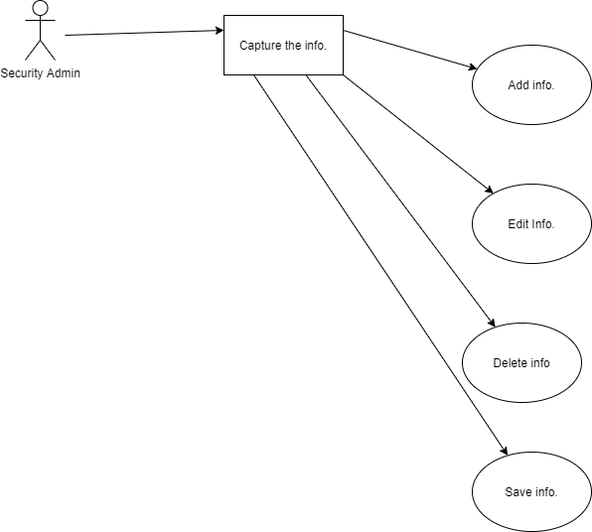

* Security Supervisor: View the report Edit the report Print the report Email the report to finance

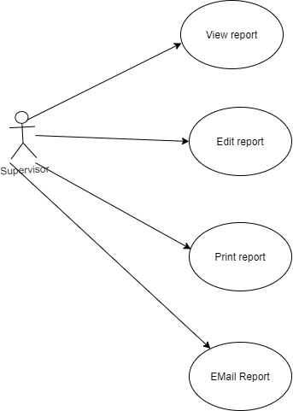

# Specifications

## Software Tools

### Programming languages

* Java –
  + For designing the front-end desktop application
* SQL –
  + For integration with the back-end database management system

### Development Environments

* Eclipse IDE for Java Developers
* Microsoft SQL Server 2014 Management Studio

## Database Schema

<To be discussed>

Required tables:

* Vehicle
* Operator
* Destination
* Department
* Reason for transport
* Trips